**Task 4- OLAP Operations (Using Redshift Or PostgreSQL)**

**1.Database Creation**

CREATE TABLE sales_sample (

Product_Id INTEGER,

Region VARCHAR(50),

Date DATE,

Sales_Amount NUMERIC

);

**2.Data Creation**

INSERT INTO sales_sample

VALUES

(201, 'East', '2023-01-01', 3213),

(202, 'Central', '2023-01-01', 3352),

(201, 'North', '2023-01-02', 1250),

(205, 'West', '2023-01-02', 6002),

(204, 'East', '2023-01-02', 850),

(205, 'North', '2023-01-02', 1100),

(201, 'Central', '2023-01-03', 950),

(204, 'South', '2023-01-03', 1150175),

(202, 'West', '2023-01-03', 32025),

(205, 'South', '2023-01-03', 102190);

**3.Perfom OLAP operations**

**(a) Drill Down: Analyze sales data at a more detailed level (Region to Product).**

SELECT Region, Product_Id, Date, SUM(Sales_Amount) AS Total_Sales

FROM sales_sample

GROUP BY Region, Product_Id, Date

ORDER BY Region, Product_Id, Date;

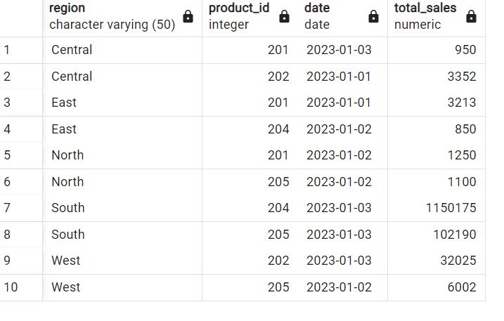

**(b) Roll Up:Summarize sales data at different levels of granularity (Product to Region).**

SELECT Product_Id, Region, SUM(Sales_Amount) AS Total_Sales

FROM sales_sample

GROUP BY Product_Id, Region

ORDER BY Product_Id, Region;

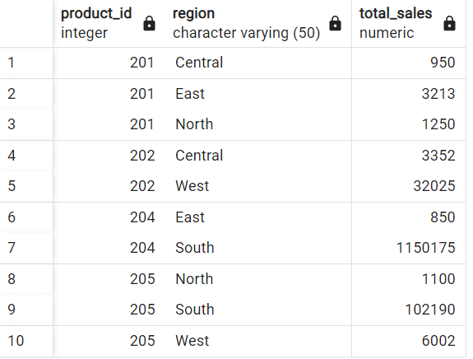

**(c) Cube: Analyze sales data from multiple dimensions (Product, Region, Date).**

SELECT Product_Id, Region, Date, SUM(Sales_Amount) AS Total_Sales

FROM sales_sample

GROUP BY CUBE (Product_Id, Region, Date)

ORDER BY Product_Id, Region, Date;

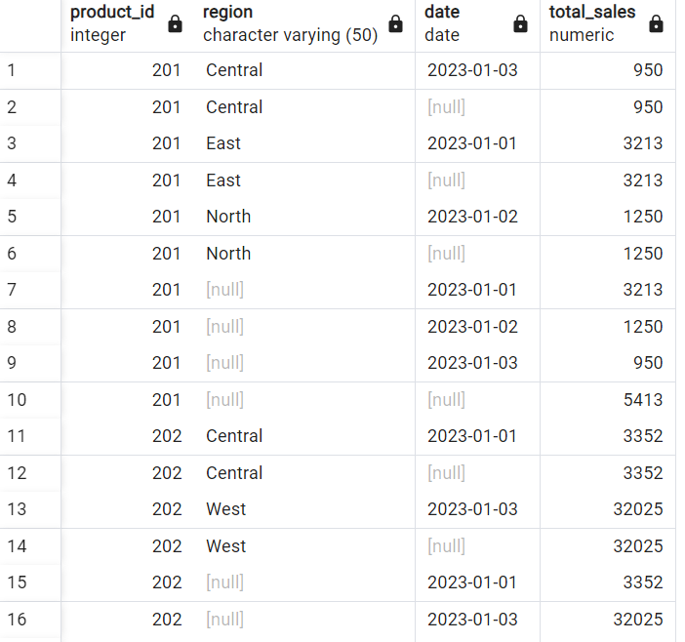

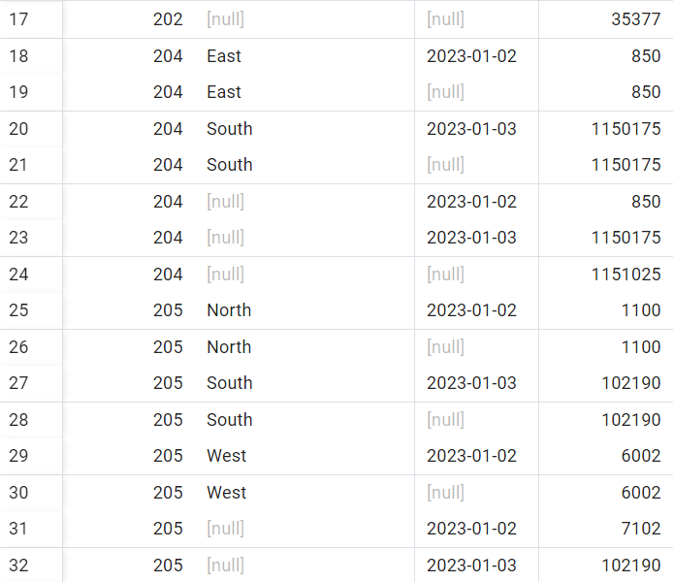

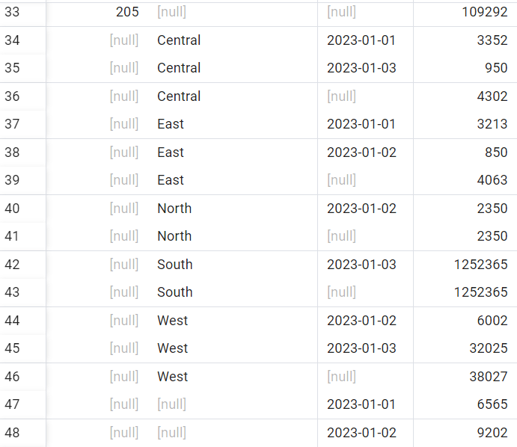

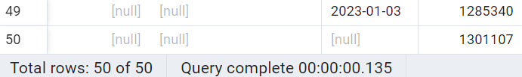

**(d) Slice:Extract a subset of data based on specific criteria (e.g., sales for a particular region).**

SELECT Region, Date, SUM(Sales_Amount) AS Total_Sales

FROM sales_sample

WHERE Region = 'East'

GROUP BY Region, Date

ORDER BY Date;

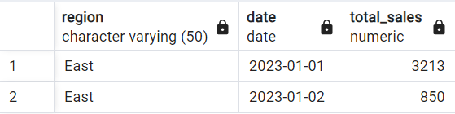

**(e) Dice: Extract data based on multiple criteria (specific combinations of Product, Region, Date).**

SELECT Product_Id, Region, Date, SUM(Sales_Amount) AS Total_Sales

FROM sales_sample

WHERE (Product_Id =201 OR Product_Id = 202) AND (Region = 'East' OR Region = 'West')

GROUP BY Product_Id, Region, Date

ORDER BY Product_Id, Region, Date;

